**Dreams of an Absolution Notes**

**Objects**

* 64 x 64 pixel art (piskellapp.com)
* Player (male teenager)
* People
* Floor
* Store
* Corruption Meter/Gauge
* Weapons
* Keys
* Walls
* Environmental Decorations (ideally 3 an area)
* Currency
* Video Cameras
* Lighting
* Light Switches
* Enemy field of view
* Quests

**Actions**

* Movement (Stealth mode, walking and running)
* Run
* Interact
* Inventory
* Stealth/Sneak
* Takedowns
* Fast movements
* Use of inventory objects
* Trade at the store

**Areas**

* Dream (Tutorial sequence)
* Uncle’s house
* City area
* City central area
* Downtown
* Subway/tube
* Safehouses
* Jail
* Offices
* Hallways
* Alleys
* Sewers
* Hospital

**U.I.**

* Inventory: Weapons, Consumables, Limited, Quests
* Menu screen
* Corruption gauge
* Currency
* Quick bind
* Sneak bar
* Sound effect bar for stealth
* Pop ups
* Fog of war
* Achievements

**Story**

* Dream
* Missing dad
* Captured uncle
* Multiple/branching ending

**Characters**

* Player
* Dad
* Uncle

**Proposed controller mapping**

* D-pad: Switch between items
* L-stick: Player Movement
* R-stick: Map Movement
* Triangle: Quick Use
* Circle: Interact
* Cross: Stealth mode toggle
* Square: Takedown/Trigger

**Tutorial Design Specification**

This specification outlines the details for the beginning of the game where the player is placed within a ‘dream’ sequence. The player will awake in this eerie world and follow a path towards the sounds of a familiar voice (his father who seemingly disappeared)

**Scene**

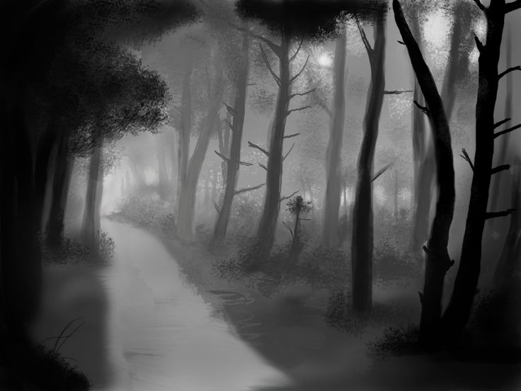Area is of an empty, eerie greyscale foggy forest with no sound aside from the chill gusts of wind

Greyscale, may have clouds of mist flowing across the screen obscuring view which flow from one side of the screen to another

World is empty aside from the trees and a straight linear ‘road’ which leads the player to their objective

Trees are black in colour, detail is minimal

Other assets include grass small bushes, texture for the ‘road’ which the player walks and the fog itself

The out-of-bounds areas of the map will be covered by dense fog to prevent the camera from seeing unused game space

**Gameplay**

The player will spawn in the scene in a large circle surrounded by trees. They will be asleep and then they will wake up. They look around and comment on their surroundings, questioning the situation. Some type of message will appear which tells the player how to move. After moving a short set distance regardless of direction (if the player moves left and then down, this distance should stack towards the distance required to trigger the following sequence), the scene will flash white (a possible transition) and the player will be transported to a new scene to that described in the scene section where they will appear on a road.

A voice (??? text box/his father) should beckon the player, prompting the player to follow the path. The voice may have additional dialogue as the player moves closer towards the objective. Upon reaching the objective the scene may flash (possibly to another new scene where everything is white) and the father (though his identify is still ambiguous to the player) should appear. Some sort dialog occurs between the two and the scene ends with the player waking up.

Do note that during this sequence only the player’s WALK movement and INTERACT function should be active. All other functions of the full control scheme should be either locked or rendered useless in the sense that they do not impact gameplay.

**Level Design**

**Scene 1:** Open greyscale circle space bordered by trees which are also bordered by more trees enshrouded in fog. Clouds of translucent mist to flow across the screen for atmosphere. No sounds, keep it eerie and ambiguous. Player spawns in the middle of this circle. Player will look around and comment on the area upon spawn. Player is transported to Scene 2 after moving a set distance which should be more than the radius of the scene to promote the use of multiple directions.

**Scene 2:** Linear road bordered by trees to suggest a forest. Text to trigger upon entering this scene prompting the player to move ‘up’ to reach the objective by which the player should comment on the familiarity of the voice. When the player is within view of the upper objective, a shadowy figure should be within view. This shadowy figure should be abstract, not humanoid and somewhat menacing.

If the player moves down, text will occur from the mysterious voice to express feelings of negativity (First, why they are leaving. Second, disappointment, and third, the lower objective, an enquiry as to why he is scared with the father appearing in front of the player). Whenever any type of text occurs from the mysterious being, the player’s movement should be stopped until exited out of. The player should also make a remark of self-reflection in response these comments. If the player moves upwards after the dismay text, the voice will first relief and then later encouragement (“Don’t be afraid”) upon reaching the upper objective. The objective can be found at both the top and bottom of the path which will transport the player to Scene 3.

**Scene 3:** Open circle similar to Scene 1 but completely empty aside from the Father and the fog which borders the area. Player spawns at bottom of scene, Father in the middle. Upon spawn, the Player will be surprised and comment “Dad…?” to which the Father will confirm and tell the player how to interact. If the player enters the fog or walks past the father (enters the upper half of the circle), they should be stopped and dialogue should occur to express dismay/ask what the player is doing whereas the player will remark on the uncertainty that his father is real and will be transported to Scene 4. If the player interacts with the father, the father will confirm his existence (“Do you remember?”) and transport the Player to Scene 4.

**Scene 4:** Full colour Scene 2 where the Father will engage with the Player, with a varying tone in text depending on what the Player did prior to entering the scene. This memory will be of a time where the Father helped teach the Player to use a slingshot to take down some stacked soda cans. During this memory, the player will very briefly be introduced to the mechanics of weaponry, prompting the use of a certain button to fire the weapon. After briefly going through the memory, the two will engage in conversation (the Player now fully believing his father is real) which will provide some minor back sight into what happened to him (the Father) and it should end with the Father telling the Player to find him before an abrupt scene transition occurs.

**Player**

The player is of a teenage boy/young adult. He should not look too edgy or stand too much. He should simply be a normal character. As the game progresses, we may possibly implement visual changes to represent his corruption in correspondence to the decisions he has made over the game. Such changes could include his hood being taken off or his hood being lower down his face for the good and bad sides respectively. We could also implement changes to his clothes to help reinforce this idea.

**Father**

Some sort of criminal who committed heinous crimes with the Player’s uncle. His wife was raped and killed by her corporation’s boss. The boss tried to cover up the incident and make it look like an accident but the father eventually found out. In response to this, the father avenged her by murdering the corporation’s boss. The death of the boss caused the corporation to crumble and brought happiness to the workers of within the corporation that the Uncle is involved in. His Uncle learned of this act and provided support to the Father, allowing for him to target other smaller corporations in a similar manner to remove them off the rivalry list and ensure the prosperity of the Uncle’s corporation. However, from these repeated actions, he descends into insanity and starts those who get in his way during his missions to target the bosses. He eventually gets found out and is hunted down by the police who catch and murder him due to his untamed hostility. They police ransack his home and the corporation takes the Player in as his relative (the Uncle) works there.

**Uncle**

The uncle is the head honcho behind the murders. Being a part of a top corporation, he was able to access secured databases to gather inside Intel on other smaller corporations which allowed for the Father to successfully infiltrate and carry out his motives. He eventually gets caught and sent to prison after the Father gets killed. Sometime during the game, the Player visits him for answers and helps him escape but the uncle is killed during the escape.

**Mechanics**

**Corruption Bar:** Core feature of the game. This changes depending on the decisions made during the game. Actions which do not prompt a decision (doing something without the game telling you to) may or may not impact this but, should it have an effect, it should be minimal when compared to that of received after making a decision prompted by the game. It should be a visible interface which the player is able to view after the game presents its first decision which will affect this bar. The level of which the bar is at should impact the behaviour of objects around the player (e.g. a high corruption level will cause guards to attack on sight whereas a sane corruption level will cause guards to send you away unharmed)

**Inventory:** An interface the player can access on the fly to view their weapons, objectives and relevant materials.

**Currency:** A storage of currency to allow for the purchase of weapons and consumables to be stored in the inventory for later use. The player should be able to pick up storable items (money, weapons, ammo) by simply walking over them. For items which cannot be walked over such as those on a desk, the interact button should allow for the player to pick it up.

**Stealth:** Activated using a toggle. This reduces the player’s natural movement speed but allows for the player to approach guards (and other related objects) undetected if outside their field of view but within their hearing range.

**Guards:** Should have a visible detection range (such as a torch) and an invisible hearing range. The behaviour of the guard should vary based on the level of corruption the player currently has and whether or not the player is armed. If the player is sneaking whilst in hearing range and the guard has not detected them, the player should remain undetected for the duration of their stealth mode unless detected during this stage whereby which the guard react appropriately in correspondence to the player’s corruption level.